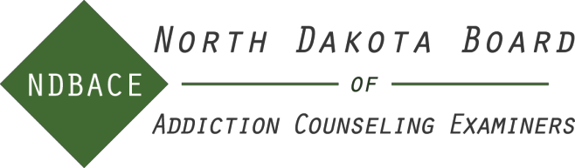
NOTICE:
All NDBACE files are subject to the North Dakota Open Records Law
RETURN FORM TO:
North Dakota Board of Addiction Counseling Examiners
1601 N 12th St Suite 609
Bismarck, ND 58501
board@ndbace.org

Guidelines for Continuing Education

All licensed addiction counselors are required to complete a minimum of forty contact hours of continuing education in a two-year period beginning January 1st of even-numbered years.

Board approved continuing education must:
- Be directly related to or supportive of addiction counseling practice
- Enhance the addiction counselor’s professional development and competence

Board approved continuing education includes:
- Workshops, refresher courses, professional conferences, seminars, education programs presented by organizations such as NAADAC, or educational, and national or state health organizations.
- In-service training at addiction facilities is acceptable for a maximum of seven contact hours per Continuing Education cycle.
- Workshops/training seminars related to personnel management or administration within an addiction
facility for a maximum of 20 contact hours per continuing education cycle. The other 20 hours of continuing education must be clinical in nature. Education with a clinical focus should enhance services provided to patients.
- Presentations by licensee of special in-services, workshops, or conferences related to addiction
counseling. A ratio of two hours of preparation time for each hour of presentation time will be awarded for a maximum of 30 contact hours per continuing education cycle. A specific presentation may be counted only once.
- Formal academic course work directly related to addiction counseling; either participating in or
instructing. One semester credit is equal to 15 Continuing Education hours. No more than 35 contact hours per continuing education cycle will be accepted.
- Authoring professional publications such as: book, chapter in a book, thesis or dissertation, article, or multimedia. Hours to be determined by the Board.
- Formal self-study course pre-approved by an organization such as NAADAC, medical associations, or
national or state health organizations with a completion certificate. A maximum of 30 hours will be allowed in the home study area, however, no single course can exceed twenty-five hours.
- Members of the Board of Addiction Counseling Examiners may be granted 20 contact hours per
continuing education cycle for serving on the board, of which 5 hours can be counted as clinical supervisory hours.
- Each Clinical Supervisor must submit three hours of clinical supervisory related continuing education
hours in order to maintain clinical supervision registration per cycle. These hours are included in the 40 hours needed for licensure renewal.
- Each licensee must submit six hours of continuing education on professional ethics.
- The Board highly recommends you keep all completion certificates and training information such as

brochures and agendas on file 4 years from the date of the training.

Continuing education hours cannot be earned until after the license effective date, and only within the current continuing education cycle

Non-acceptable continuing education topics include (but are not limited to):
- Those contrary to the NAADAC code of ethics
- Marketing, business, personal enrichment, time management, supervisory sessions, technology enhancement, staff orientation, agency, or other meetings regarding procedural issues
- CPR classes
- Computer-related workshops

Continuing Education Audit
The board’s Administrative Rules give the following information about the continuing education audit:

- At the end of the two-year reporting cycle, each licensee or registrant shall submit a signed statement on a
form provided by the board attesting to satisfaction of the continuing education requirement. The licensee or registrant shall list the activities submitted for continuing education credit and the amount of credit claimed for each one and the date for each session.
- The licensee or registrant may not submit the specific verification of each continuing education
experience claimed, but must maintain a file of such verification documentation for two years following the submission of the reporting form.
- At each reporting period, the board will select a random sample of approximately ten percent of the
licensees and registrants and require them to provide verification of the continuing education experiences claimed on the reporting form.

Licensees seeking pre-approval of continuing education hours must submit the Approved Program Application form to the board office. Final determination of the acceptability of continuing education hours rests with the NDBACE.

